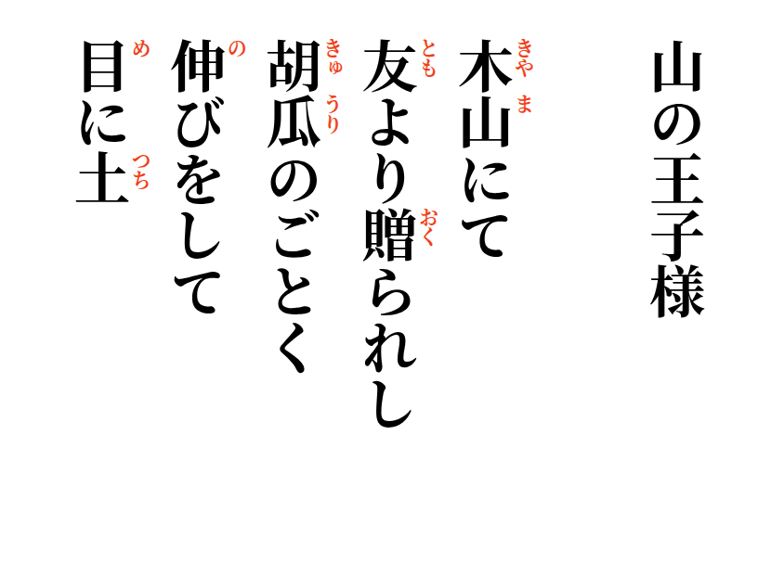

2026-09-17
Prince on the Mountain
Upon the wooden mountain,
like the cucumber
given by dear friends,
he stretches long—
dirt still in his eye.

